**#Mobile Computing Assignment 1**

**20181257 최찬혁**

## Our goal is to implement three features:

1. Upload/delete a floor map from photo album
2. Wardriving mode: choose a position on the map, scan APs, save the collected information
3. Real-time localization mode: scan APs and find the fittest position and show the position on the map

## My development environment:

* Language: Java
* Minimum SDK: API 16: Android 4.1 (Jelly Bean)
* Target SDK: API 33

## For these functions, I composed my application’s structure as follows:

* ‘MainActivity’ is the main activity of my application and contains the logic for handling the image upload, war-driving mode, and localization mode. It also registers a broadcast receiver to listen for Wi-Fi scan results. The activity allows the user to select a location on an image and perform actions such as adding new Wi-Fi data, deleting data, or viewing saved data for that location.
* ‘SeeActivity’ is launched when the user wants to view the saved Wi-Fi scan results for a particular location. It receives the scan results as a serializable extra and displays them in a scrolling text view.
* ‘ScanActivity’ is launched when the user wants to perform a Wi-Fi scan for a particular location. It checks for the necessary permissions and registers a broadcast receiver to receive scan results. The activity displays the scan results in a scrolling text view.

## Implementation Details:

1. Upload/delete a floor map:

If a user clicks the ‘uploadMap’ button, then he/she can select an image in the device’s album. In this assignment, I would select 106 1F image (or 106 2F image).



1. Wardriving mode:

Since this written code lines are too long, I decide to omit to attach the codes directly. You may see the specific codes in the attached code file.

A toggle button is used to operate ‘mode’. So, if the ‘wardriving’ button is clicked, user can modify the uploaded image by adding or removing points on it. And if user is located on the specific position with respect to the image and click the spot on the image, the clicked spot is denoted with a blue point and a dialog appears for asking whether you want to scan Wi-fi Access Points or not. If he/she selects ‘Yes’, ‘ScanActivity’ would be launched and show scan results on the screen. Then, user may also choose ‘Yes’ or ‘No’ in order to save Wi-fi APs on the point:

1. Save ‘Yes’: After returning to ‘MainActivity’, the point’s color is changed to red and it saves the position(In particular, modified position related to the image coordinate) and ScanResults(List<ScanResult>) in form of List.
2. Save ‘No’: After returning to ‘MainActivity’, the blue point disappears, and user can keep interacting with app.

If there are several red points having their position and scan-results (Actually, they are stored as List<PointF> locationPoints & <List<List<ScanResult>>> scanResults), a user can choose & click a specific point. Then, another dialog would appear for asking whether you may do additional tasks or not:

1. Add new Wifi data: ‘ScanActivity’ would be launched with the passed arguments (scan-result) by an index. And re-scanned Wi-fi APs on the location would be shown on the screen. If the user clicks ‘Yes’ button, the scanResults’ value by the index would be changed with the new Wifi APs.
2. Delete the data: The specific position and scan-result would be deleted by an index.
3. See the data: ‘SeeActivity’ would be launched with the passed arguments (scan-result) by an index.
4. Cancel: Do not anything.
5. Real-time localization mode:

A toggle button is also used to operate ‘mode’. If the toggle is checked, BroadcaseReceiver and IntentFilter are registered and startTimeTask() would begin. Then, WifiManager do startScan() every 5 seconds after delayed 1s and a current location would be estimated from WifiManager.getScanResults(): Three highest RSSI (level) intensity of the current scanned Wifi APs are picked and compared with scanReults as results of wardriving. If these intensities differences are small (<1), a location point matched to the scan-result by the index would be returned. Then, the current position will be denoted with a blue point on the image. If there’s no matched Wi-fi APs, that notification would be shown on the screen.

** Note: My device (Samsung Galaxy Note 10+) limited Wi-fi scans only four times since the device system force to restrict the usage of wifi-scan. (i.e., The WifiManager.startScan() usage is limited to: - Each foreground app is restricted to 4 scans every 2 minutes). So, the experiments are restricted, please consider it. **





## Experimental results:

1. Upload/delete a floor map:

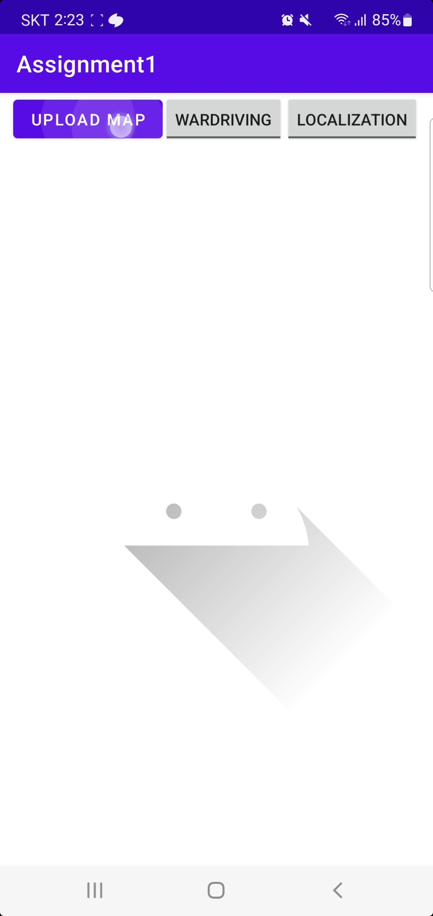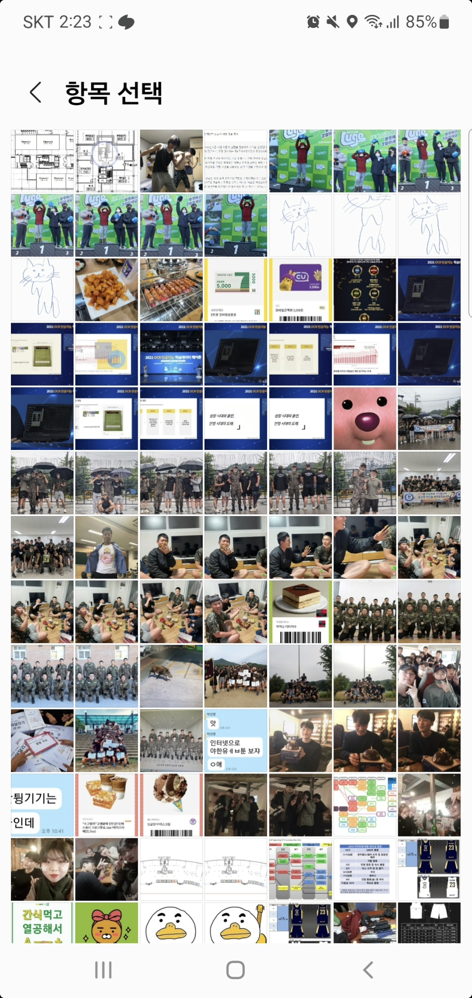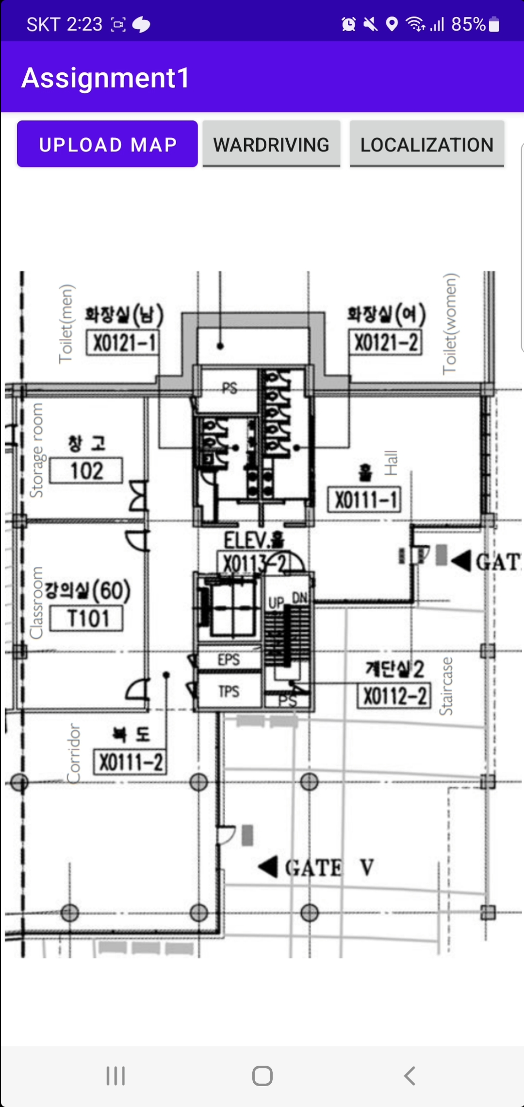

1. Wardriving mode:

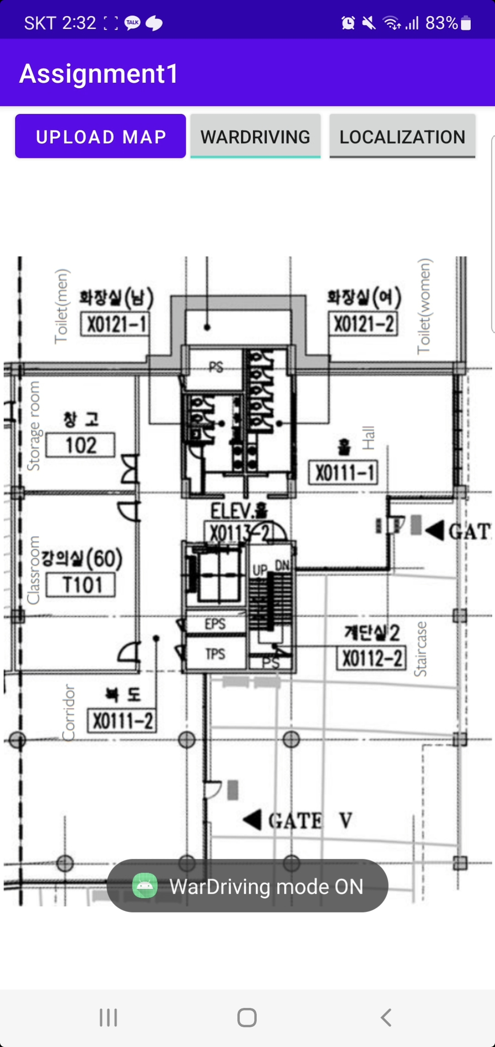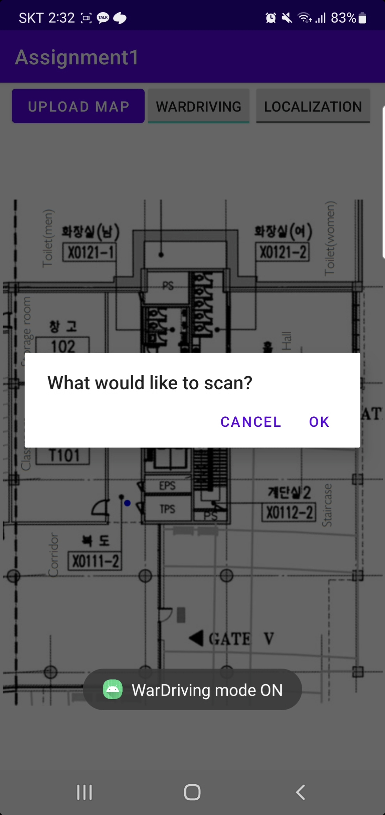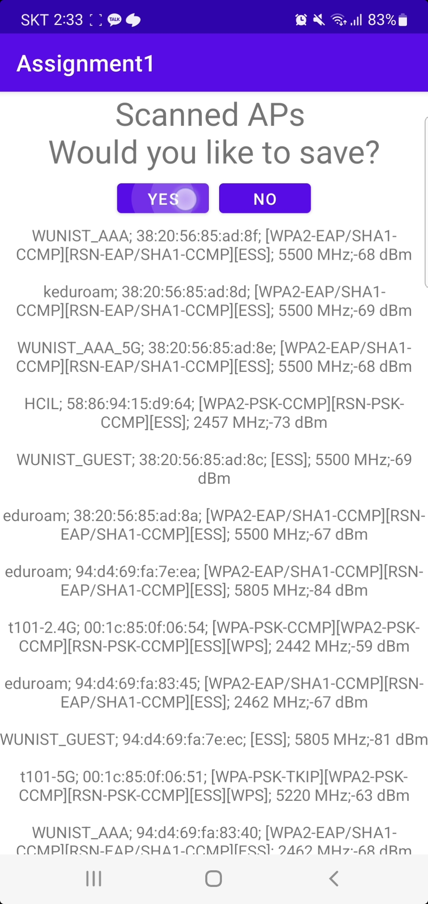

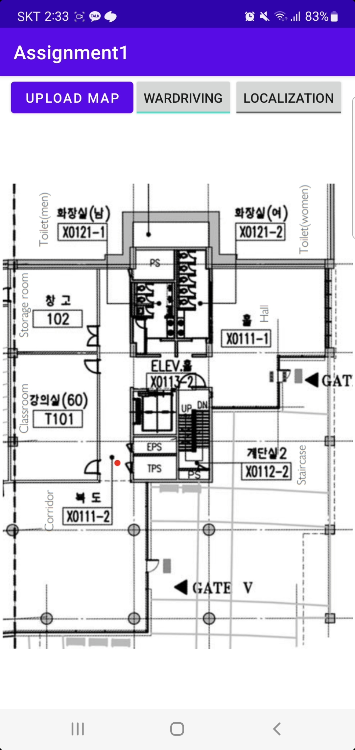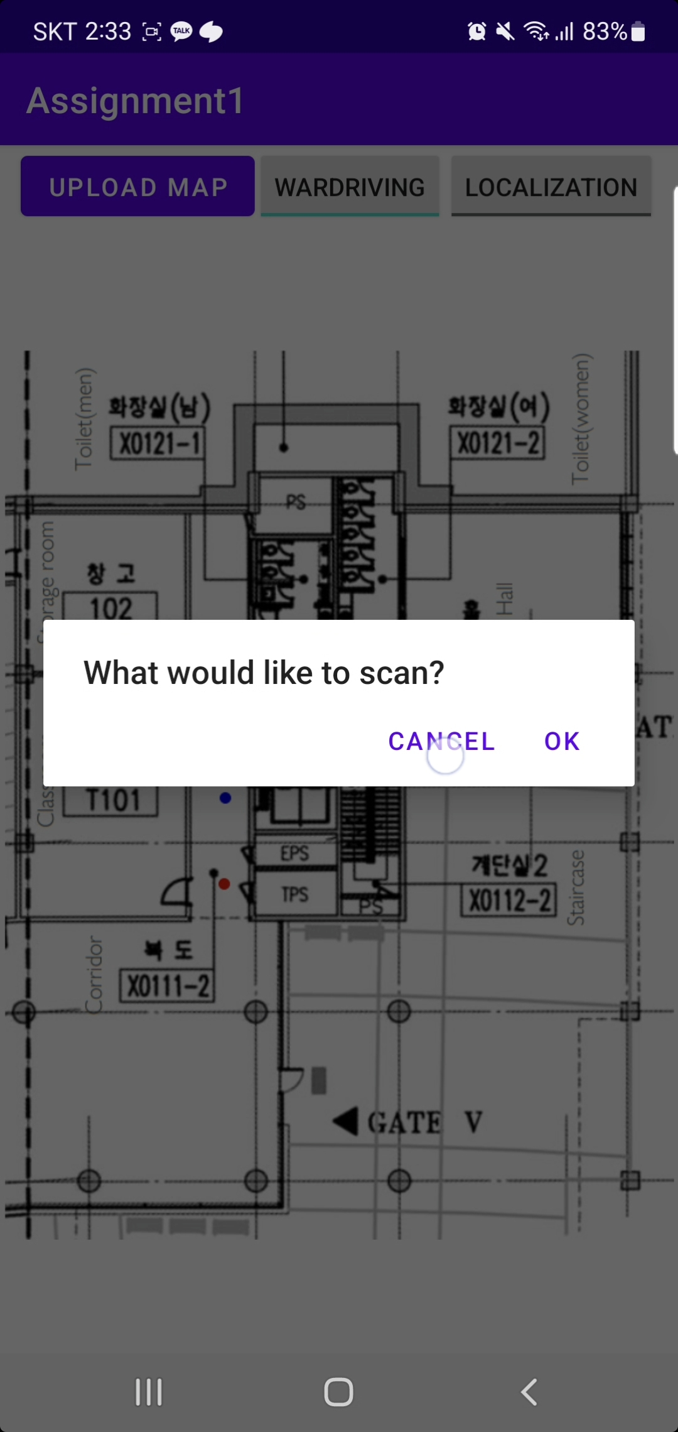

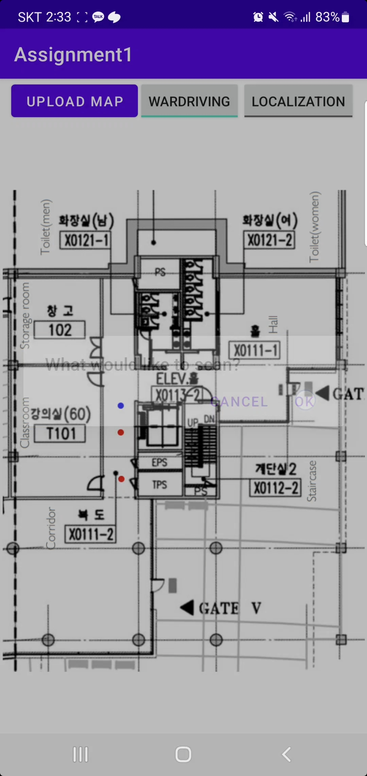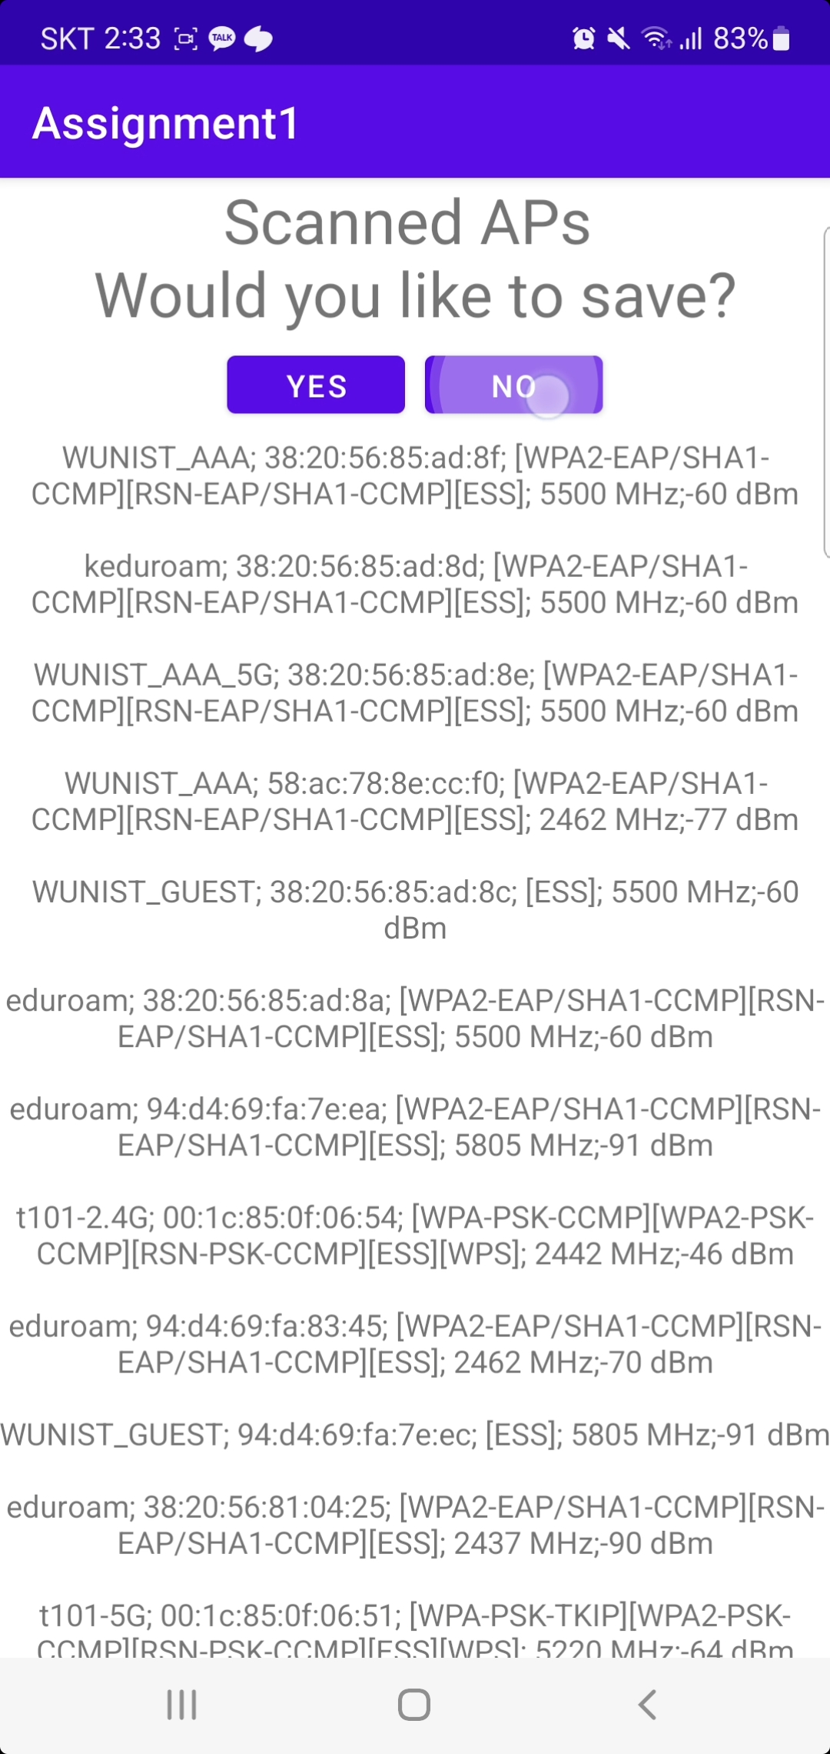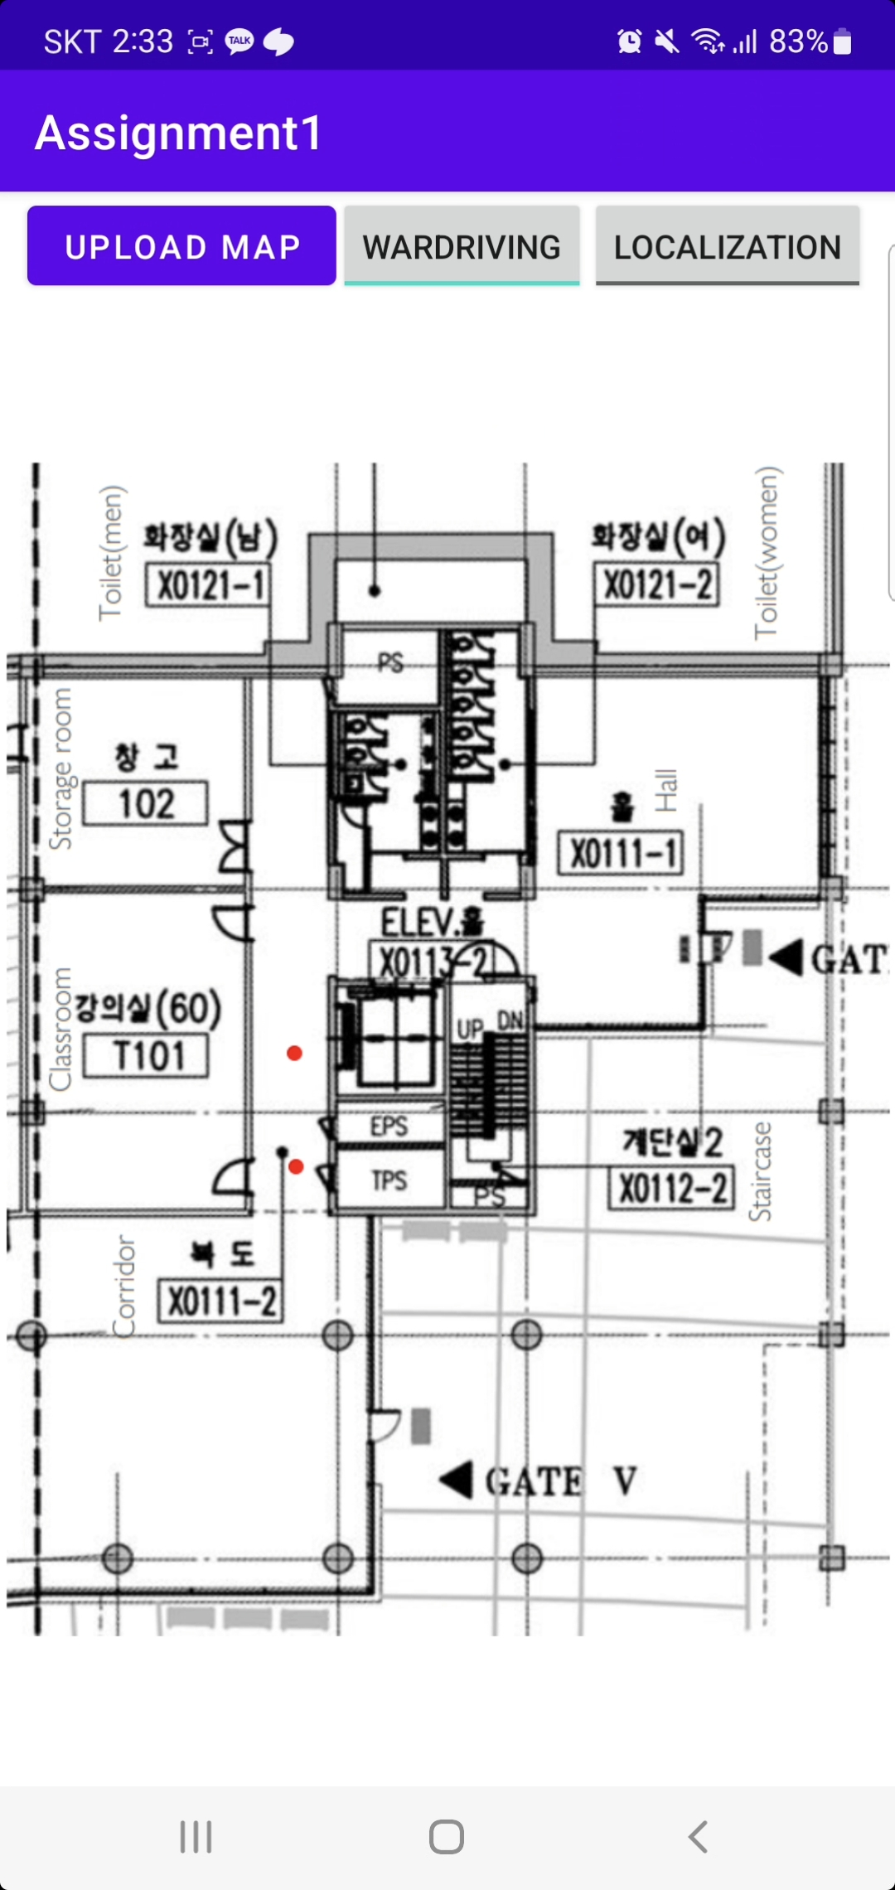

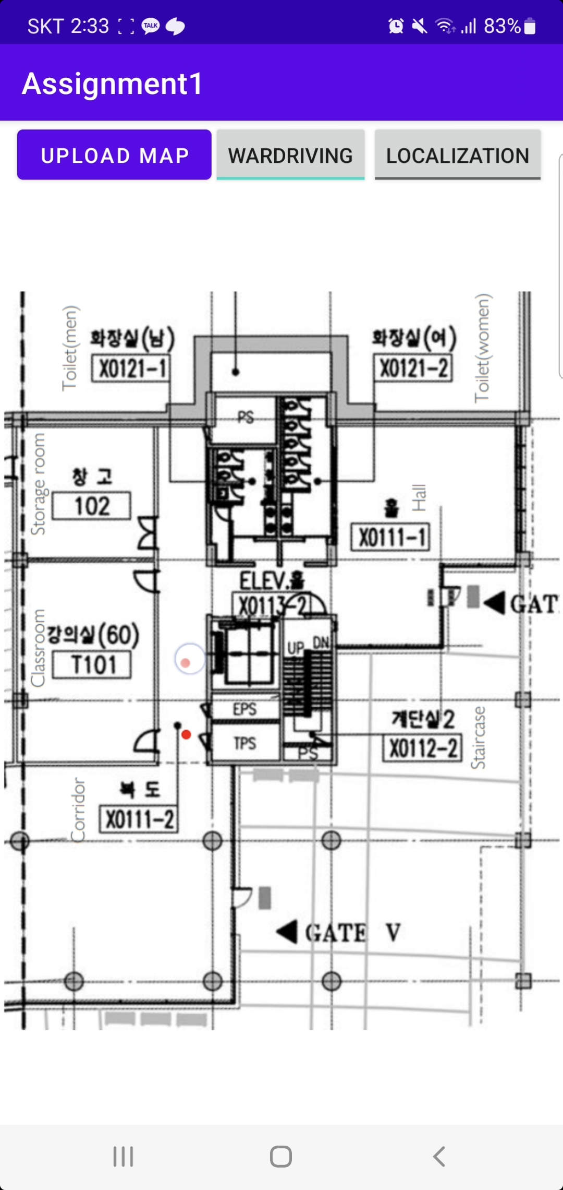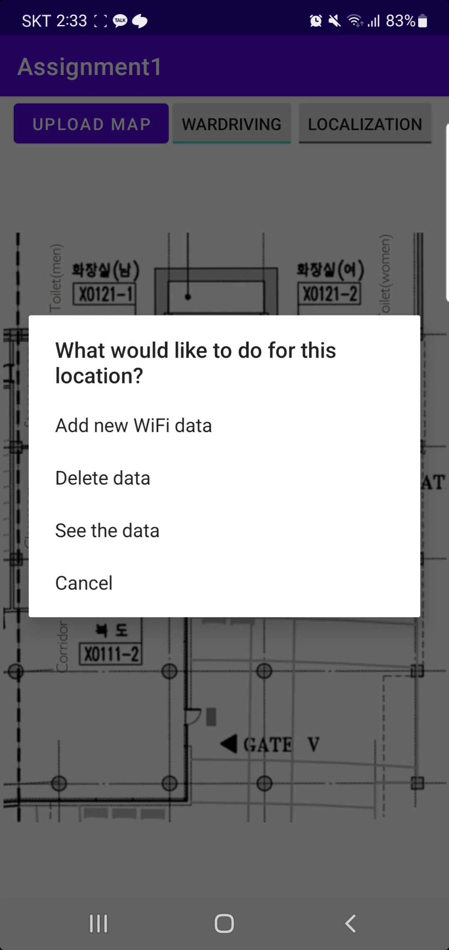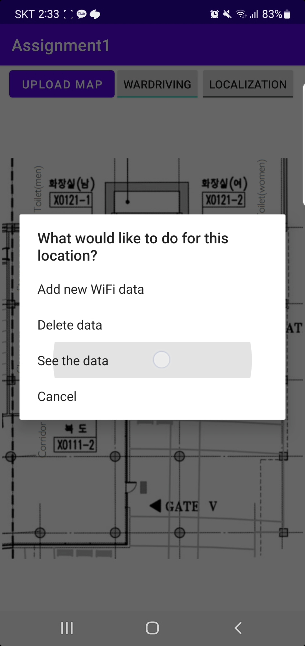

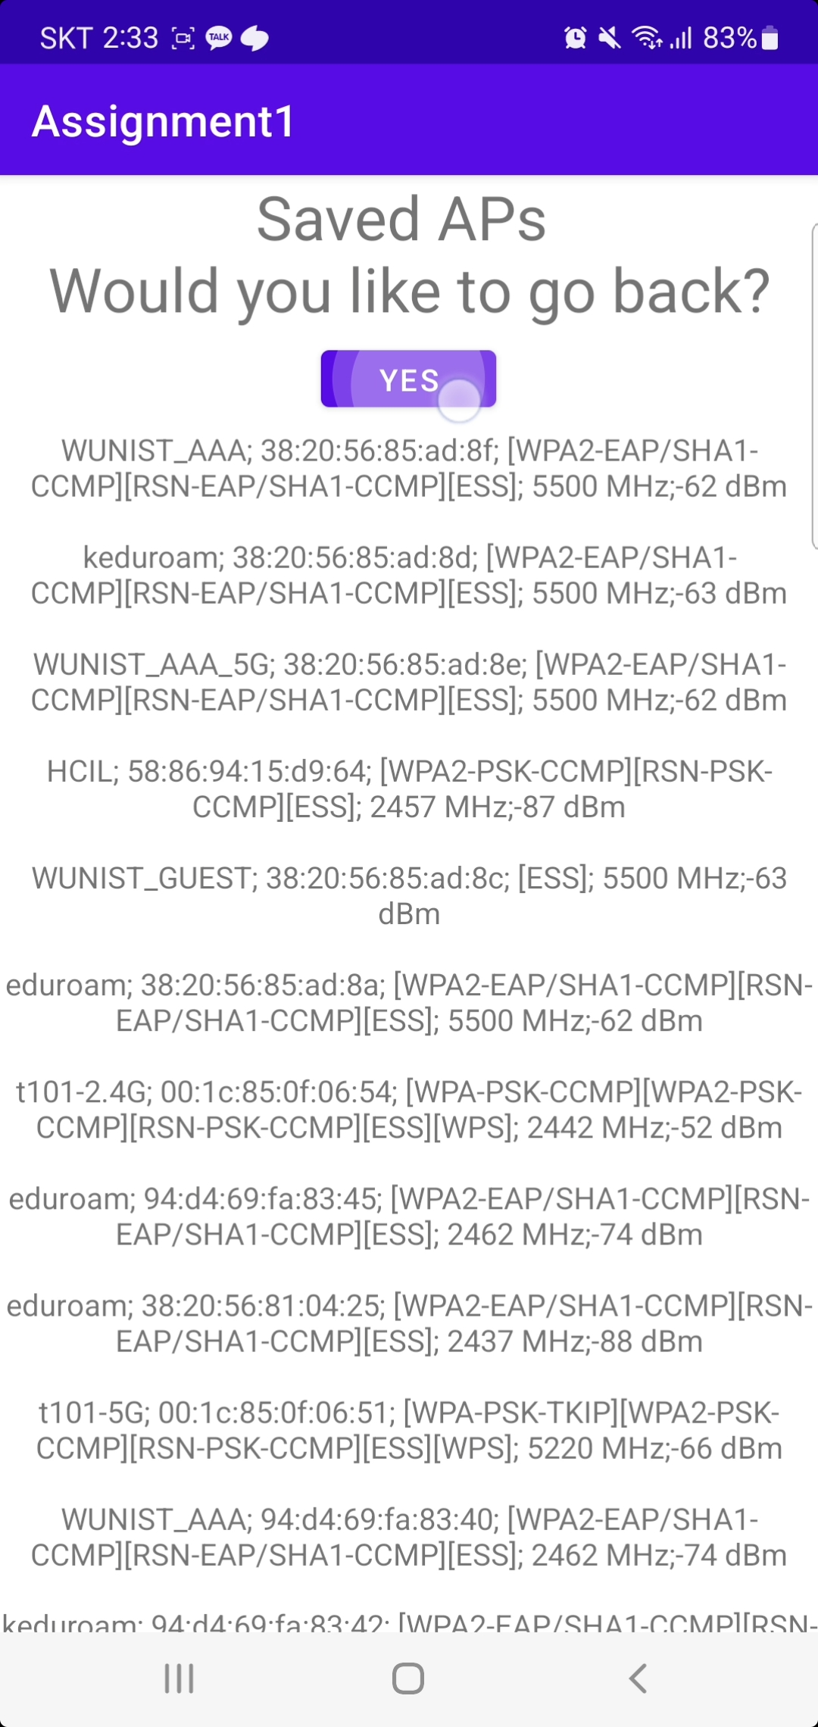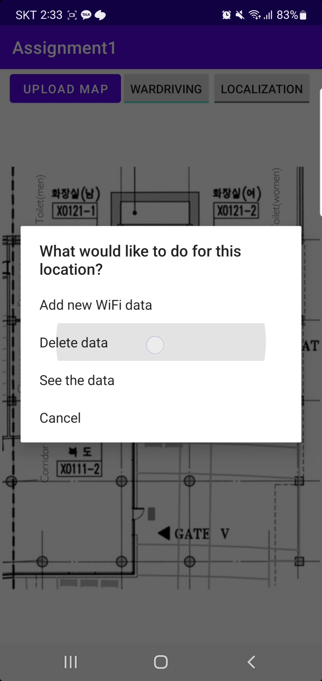

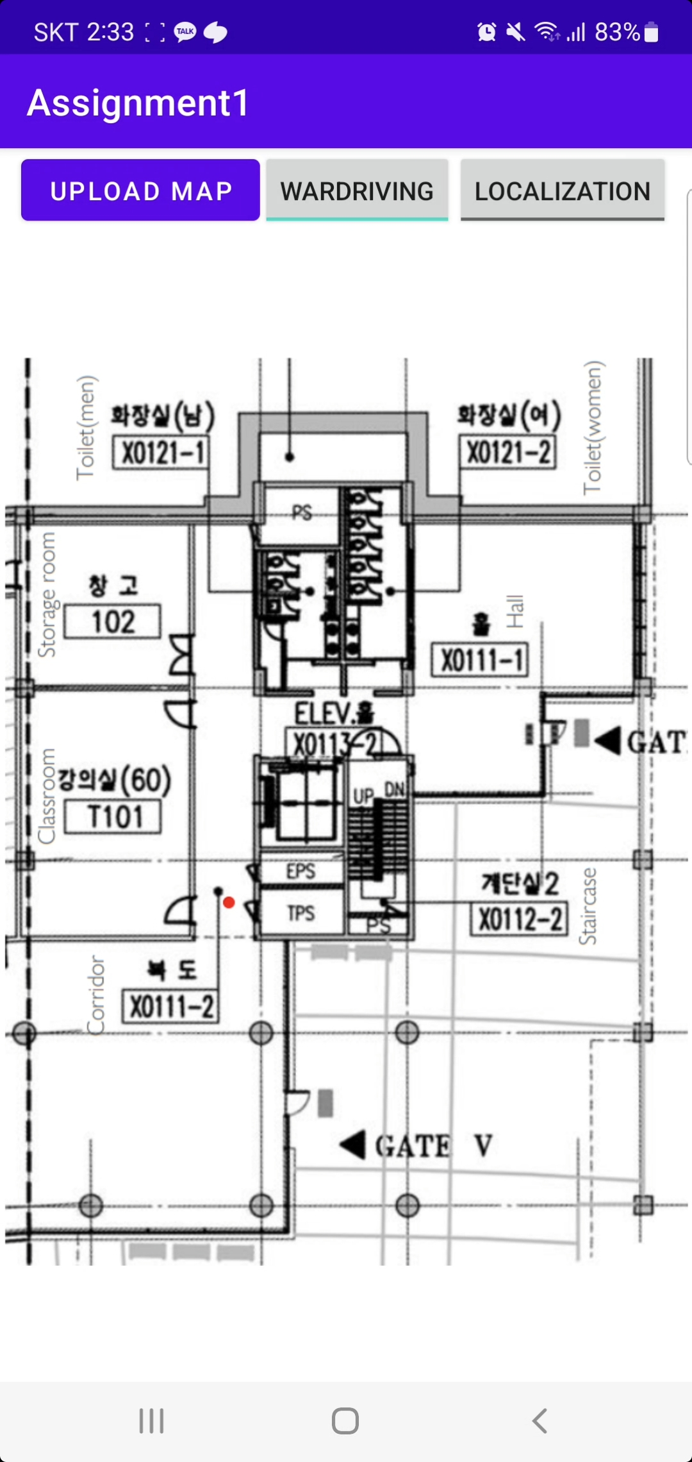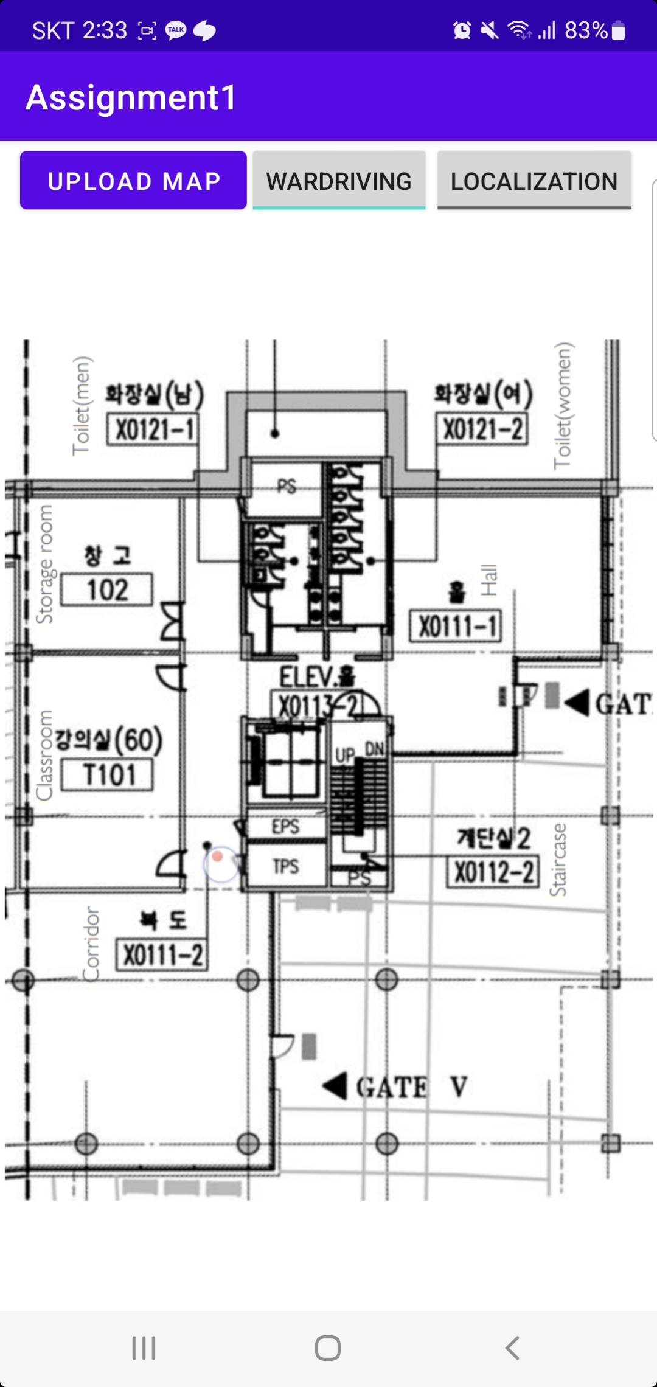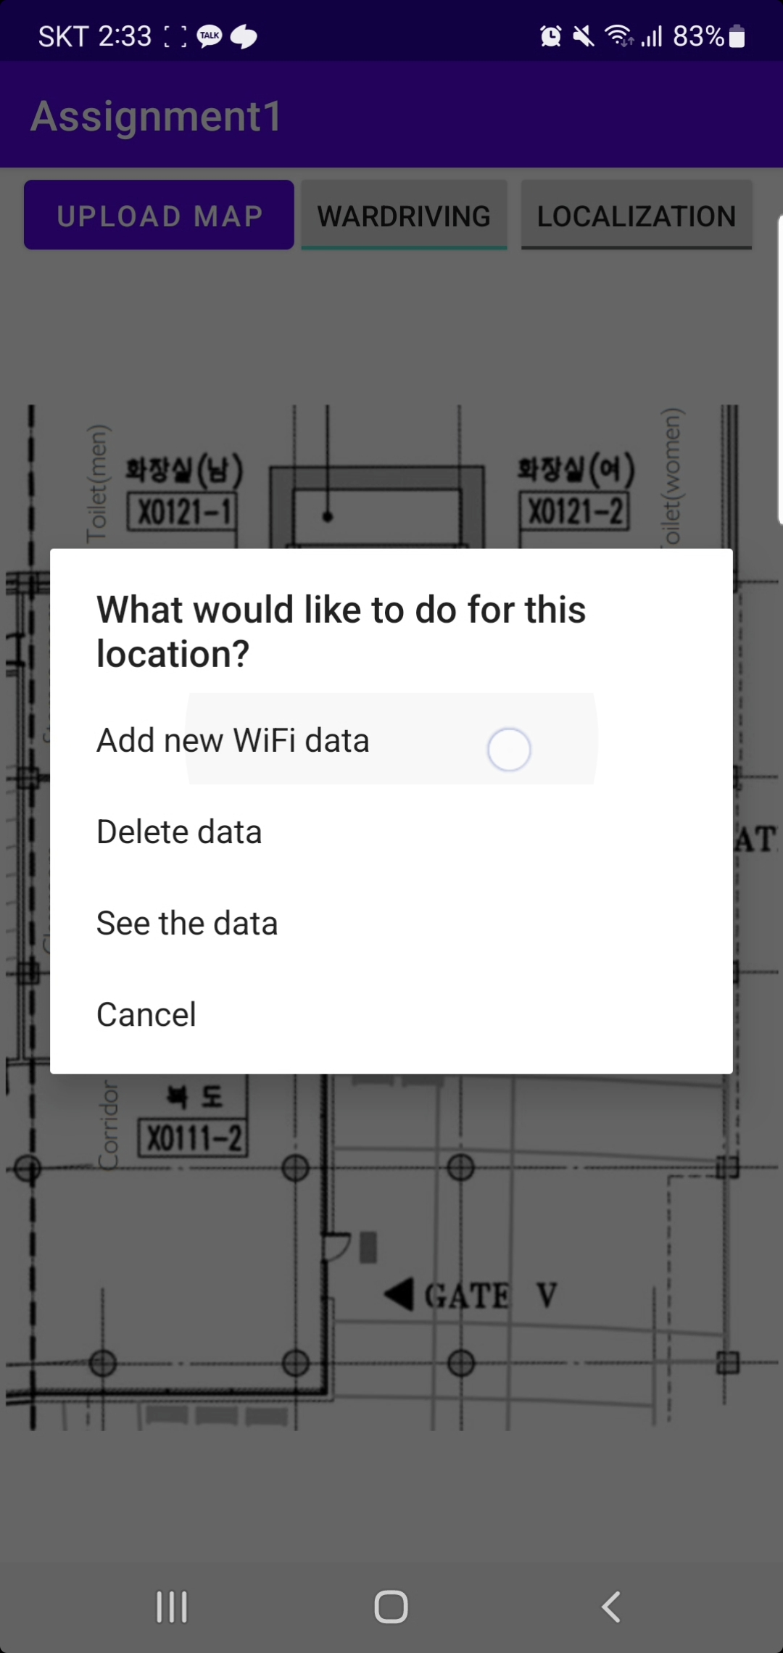

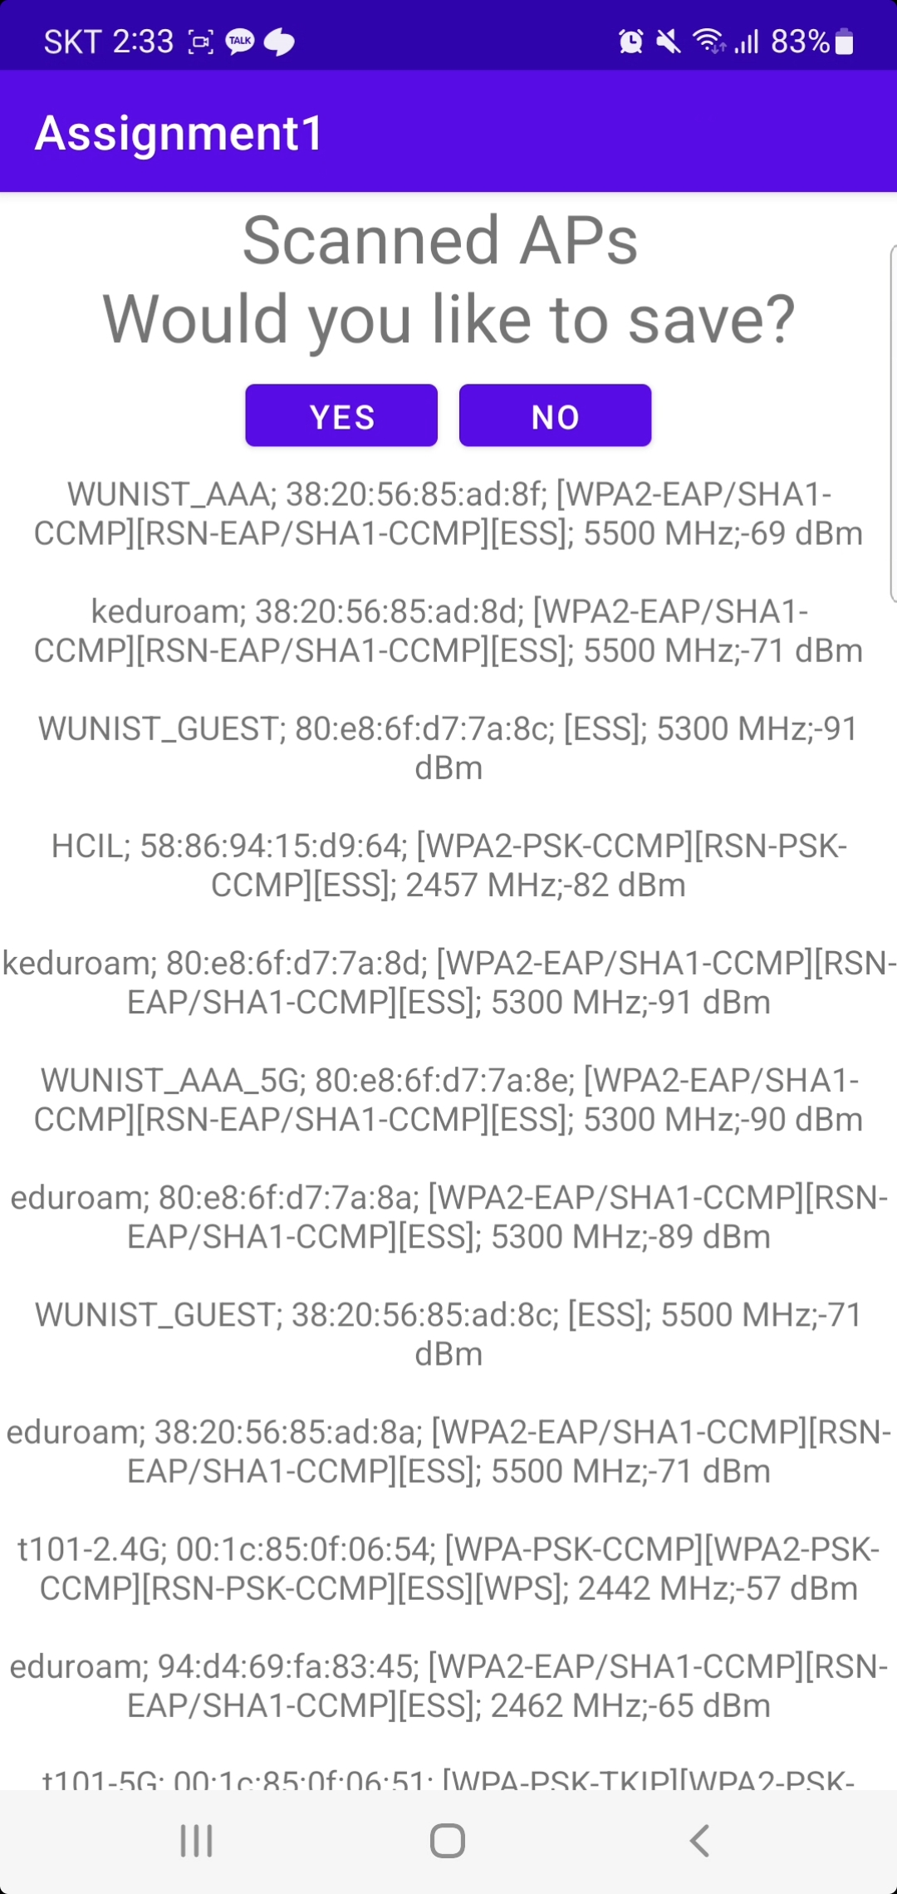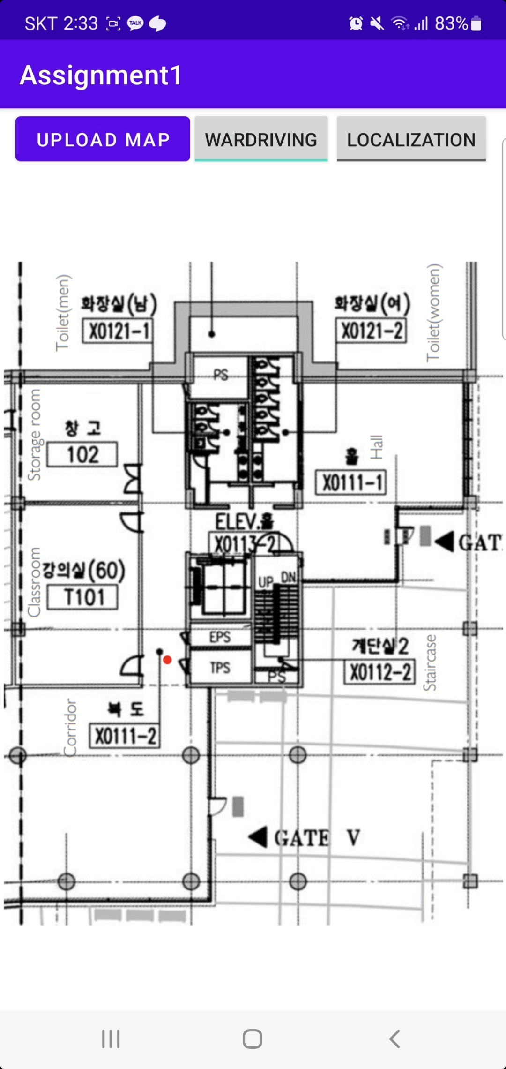

1. Real-time localization mode:

